# Assignment -4

|  |  |
| --- | --- |
| Assignment Date | 18 October 2022 |
| Student Name | R.Divyasree |
| Student Roll Number | 820419104021 |
| Maximum Marks | 2 Marks |

**Question-1:** Create a Bucket in IBM object storage.

# Solution:

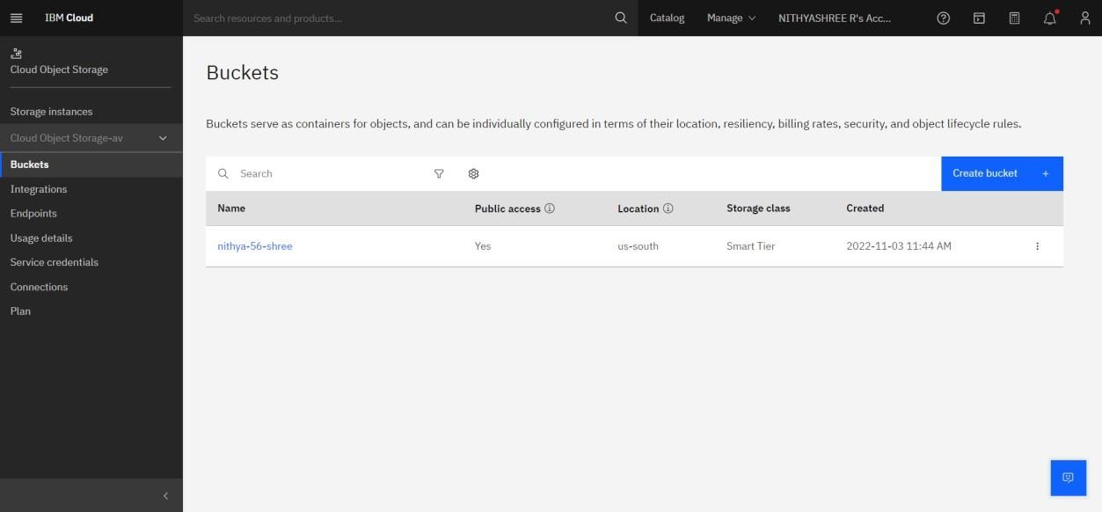

**Question-2:** Upload an 5 images to ibm object storage and make it public. write html code to displaying all the 5 images.

# Solution:

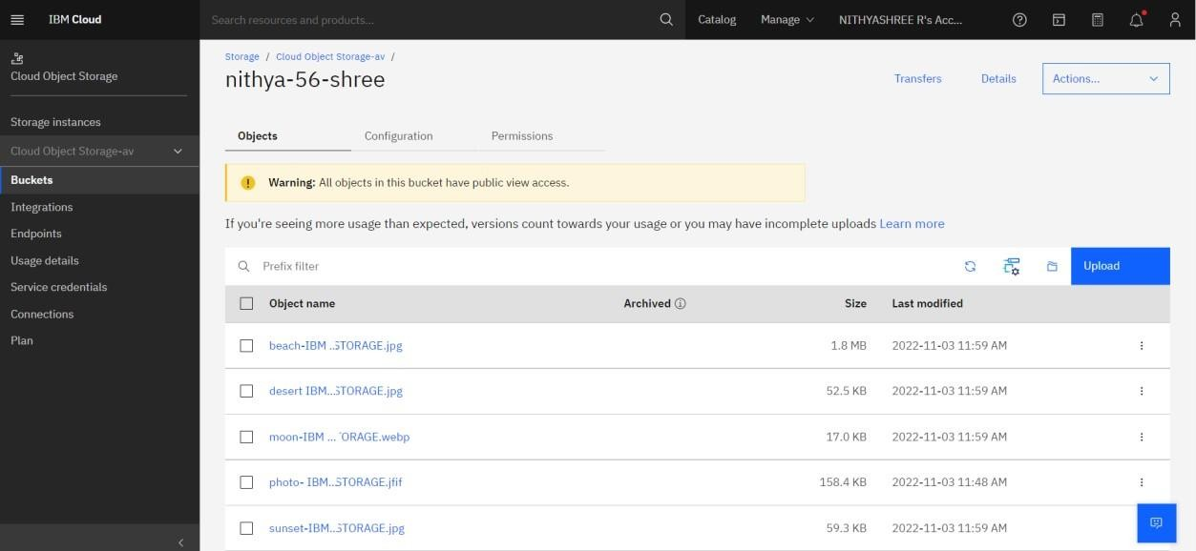

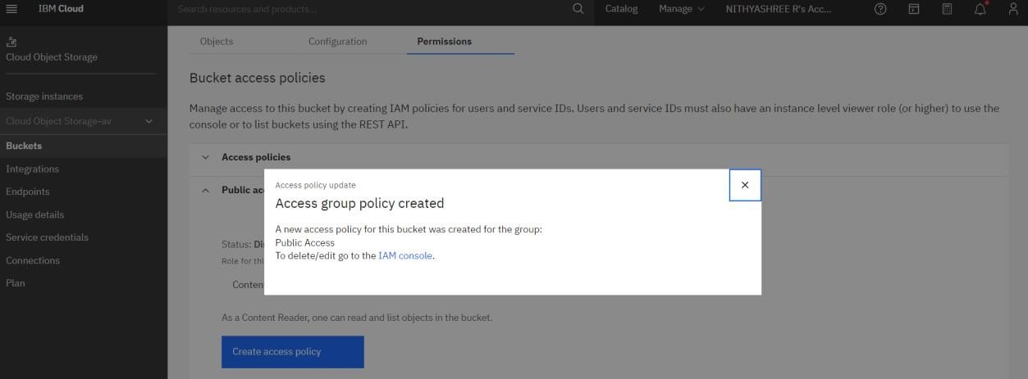

HTML CODE

<!DOCTYPE html>

<html>

<head>

<title>HTML Cloud Storage Buckets</title>

</head>

<body>

<div class="container">

<img src =

"https://divya-06-sree.s3.us-south.cloud-object- storage.appdomain.cloud/beach-IBM%20OBJECT%20STORAGE.jpg"

alt = "hp" height = "250" width = "270" />

<img src =

"https:// divya-06-sree.s3.us-south.cloud-object- storage.appdomain.cloud/desert%20IBM%20OBJECT%20STORAGE.jpg"

alt = "hp 1" height = "250" width = "270" />

<img src =

"https:// divya-06-sree.s3.us-south.cloud-object- storage.appdomain.cloud/moon-IBM%20OBJECT%20STORAGE.webp"

alt = "hp 2" height = "250" width = "270" />

<img src =

"https:// divya-06-sree.s3.us-south.cloud-object- storage.appdomain.cloud/photo-%20IBM%20OBJECT%20STORAGE.jfif"

alt = "hp 3" height = "250" width = "270" />

<img src =

"https:// divya-06-sree.s3.us-south.cloud-object- storage.appdomain.cloud/sunset-IBM%20OBJECT%20STORAGE.jpg"

alt = "hp 4" height = "250" width = "270" />

</div>

</body>

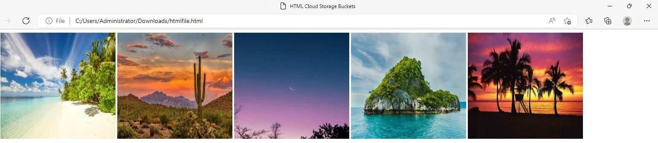

**Question-3:** Upload a css page to the object storage and use the same page in your HTML code.

# Solution:

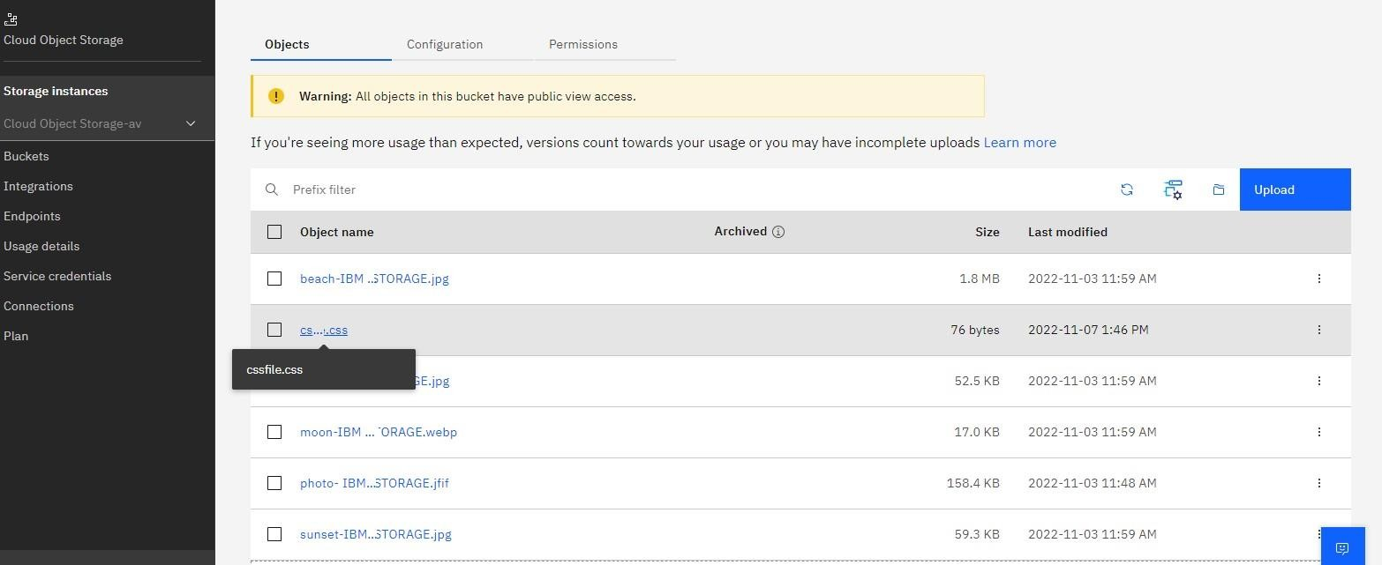

**HTML CODE**:

<!DOCTYPE html>

<html>

<head>

<title>HTML & CSS Cloud Storage Buckets</title>

<style> title{

color: white;

text-align: center; font-weight: bold; font-family: Bodoni Mt;

}

</style>

<link rel="stylesheet" href="cssfile.css">

</head>

<body>

<div class="container">

<img src =

"https:// divya-06-sree.s3.us-south.cloud-object- storage.appdomain.cloud/beach-IBM%20OBJECT%20STORAGE.jpg"

alt = "hp" height = "250" width = "270" />

<img src =

"https:// divya-06-sree.s3.us-south.cloud-object- storage.appdomain.cloud/desert%20IBM%20OBJECT%20STORAGE.jpg"

alt = "hp 1" height = "250" width = "270" />

<img src =

"https:// divya-06-sree.s3.us-south.cloud-object- storage.appdomain.cloud/moon-IBM%20OBJECT%20STORAGE.webp"

alt = "hp 2" height = "250" width = "270" />

<img src =

"https:// divya-06-sree.s3.us-south.cloud-object- storage.appdomain.cloud/photo-%20IBM%20OBJECT%20STORAGE.jfif"

alt = "hp 3" height = "250" width = "270" />

<img src =

"https:// divya-06-sree.s3.us-south.cloud-object- storage.appdomain.cloud/sunset-IBM%20OBJECT%20STORAGE.jpg"

alt = "hp 4" height = "250" width = "270" />

</div>

</body>

# CSS file:

body

{

background-image: url('closeup.jpg'); width:100%;

height:100%;

}

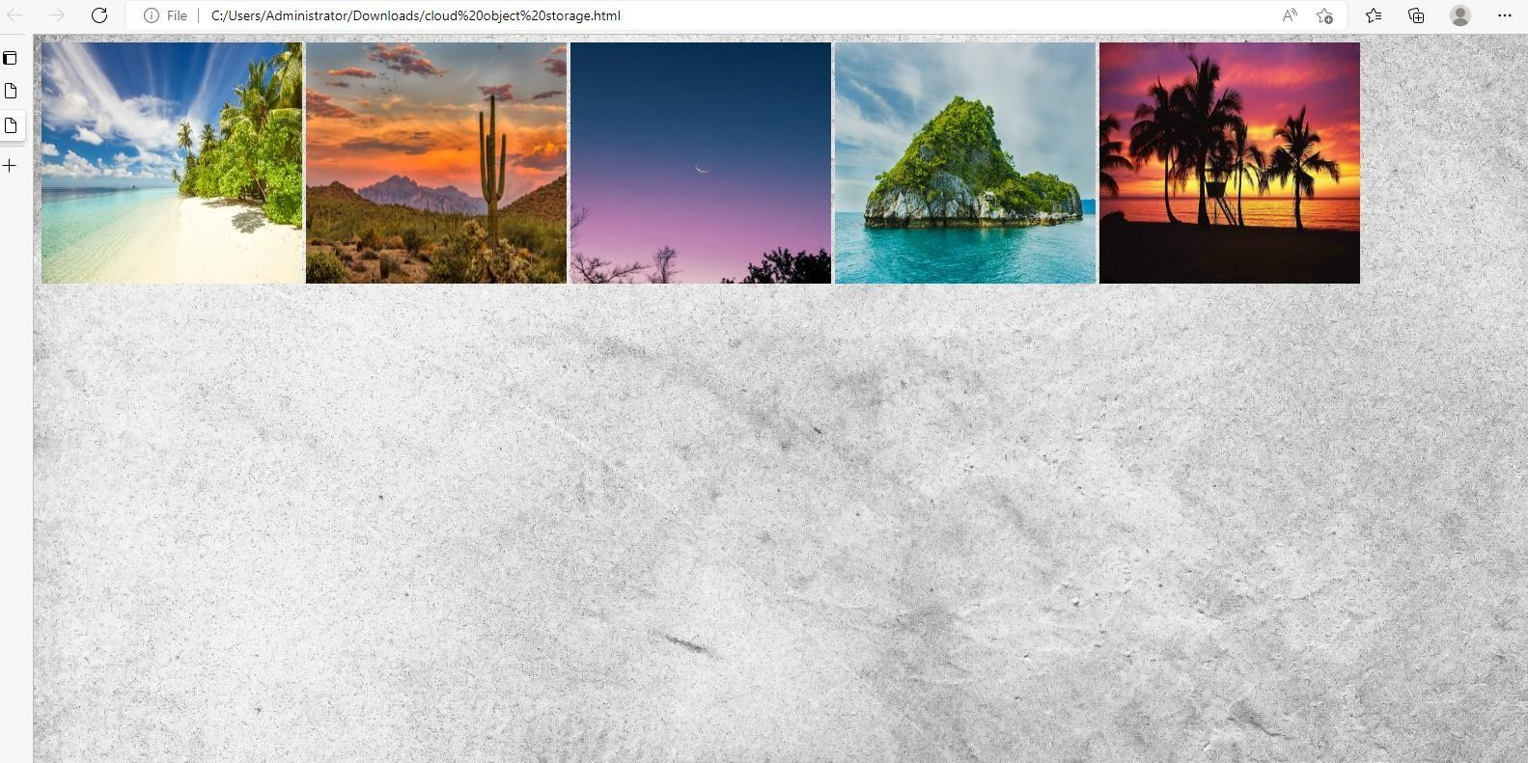

IMAGES UPLOADED IN CLOUD STORAGE:











**Question-4** Design a chat bot using IBM Watson assistant for hospital. Ex: User comes with query to know the branches for that hospital in your city. Submit the web URL of that chat bot as a assignment.

# Solution:

**CHATBOT URL:**

chat.global.assistant.watson.appdomain.cloud/preview.html?backgroundImageURL=https%3A%2F%2Fus-south.assistant.watson.cloud.ibm.com%2Fpublic%2Fimages%2Fupx-51ccf44d-52c8-42ba-b034-6745a47e2f8a%3A%3Aa5cd1dcf-76a2-41b5-803a-ce72ce6a1ae6&integrationID=a1fecb98-2c1d-4d1d-b93b-26391d6efda1&region=us-south&serviceInstanceID=51ccf44d-52c8-42ba-b034-6745a47e2f8a

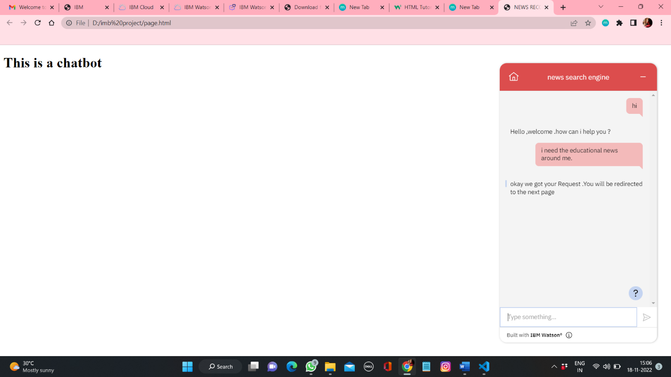

# Question-5:

Create Watson assistant service with 10 steps and use 3 conditions in it. Load that script in HTML page

# Solution:

**CHATBOT URL:**

chat.global.assistant.watson.appdomain.cloud/preview.html?backgroundImageURL=https%3A%2F%2Fus-south.assistant.watson.cloud.ibm.com%2Fpublic%2Fimages%2Fupx-51ccf44d-52c8-42ba-b034-6745a47e2f8a%3A%3Aa5cd1dcf-76a2-41b5-803a-ce72ce6a1ae6&integrationID=a1fecb98-2c1d-4d1d-b93b-26391d6efda1&region=us-south&serviceInstanceID=51ccf44d-52c8-42ba-b034-6745a47e2f8a

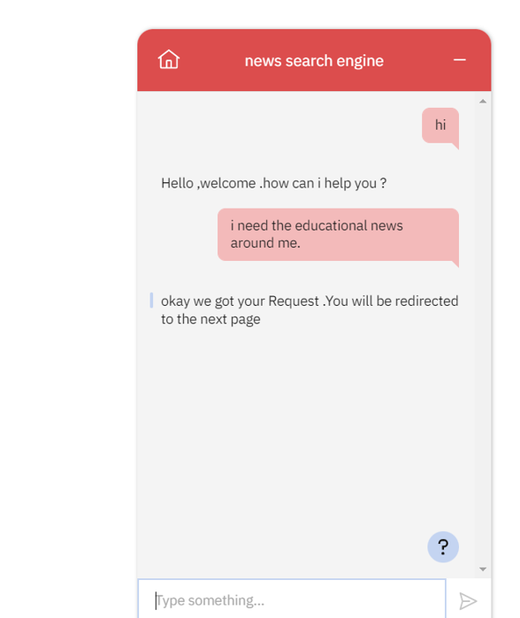

<!DOCTYPE html>

<html>

<head>

<title>NEWS RECOMMENDER APPLICATION</title>

<script>

    window.watsonAssistantChatOptions = {

      integrationID: "a1fecb98-2c1d-4d1d-b93b-26391d6efda1", // The ID of this integration.

      region: "us-south", // The region your integration is hosted in.

      serviceInstanceID: "51ccf44d-52c8-42ba-b034-6745a47e2f8a", // The ID of your service instance.

      onLoad: function(instance) { instance.render(); }

    };

    setTimeout(function(){

      const t=document.createElement('script');

      t.src="https://web-chat.global.assistant.watson.appdomain.cloud/versions/" + (window.watsonAssistantChatOptions.clientVersion || 'latest') + "/WatsonAssistantChatEntry.js";

      document.head.appendChild(t);

    });

  </script>

</head>

<body>

<h1>This is a chatbot</h1>

</body>

</html>

